**AWS Blogs:** [**https://aws.amazon.com/blogs/aws/**](https://aws.amazon.com/blogs/aws/)

**AWS Forums (community):** [**https://forums.aws.amazon.com/index.jspa**](https://forums.aws.amazon.com/index.jspa)

**AWS Whitepapers and Guides:** [**https://aws.amazon.com/whitepapers**](https://aws.amazon.com/whitepapers)

**AWS Partner Solutions (formerly quickstarts):** [**https://aws.amazon.com/quickstart/**](https://aws.amazon.com/quickstart/)

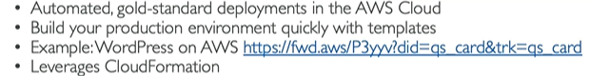

**AWS Solutions:** [**https://aws.amazon.com/solutions**](https://aws.amazon.com/solutions)

